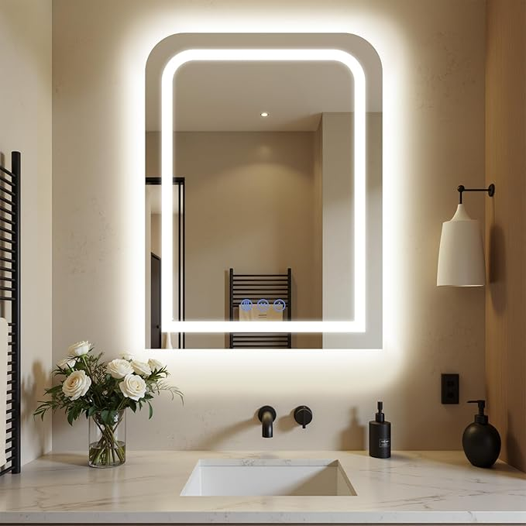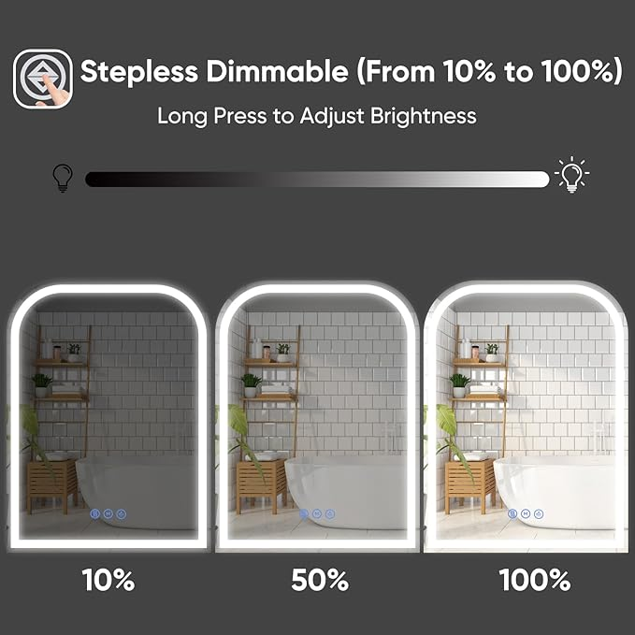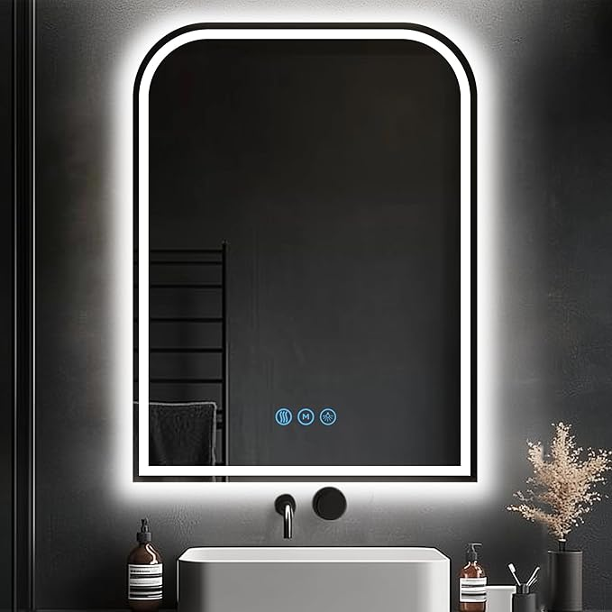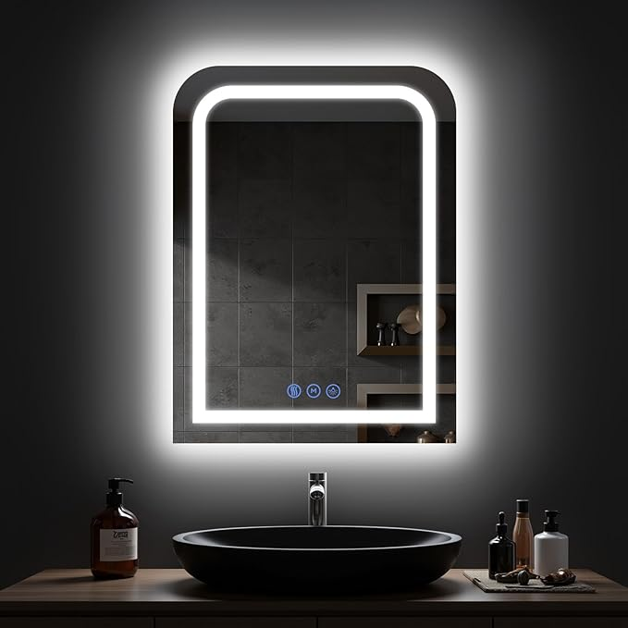

LED Bathroom Mirror, 24"x 32" LED Mirror with Lights for Bathroom, Lighted Vanity Mirrors for Wall, Anti-Fog, Dimmable, Tempered Glass, Memory Function, 3 Colors, Safe Use (White)

**PRODUCT DESCRIPTION:**

|  |  |
| --- | --- |
| Brand | Antok |
| Room Type | Bathroom |
| Shape | Semi-Circle |
| Product Dimensions | 24"L x 32"W |
| Frame Material | Aluminum |

**About this item**

* 【Backlit+Front-lit, Double Super Lighting Sources】:Antok LED bathroom mirror is designed with both backlight and front light. The lighting is bright enough for makeup or shave or beauty care. No dark, no shadow, super clear.
* 【Dimmable & 3 Speed Color Temperature】: The brightness is dimmable for this lighted bathroom mirror. By simply long press the touch switch to adjust the brightness. Both backlight and front light could be dimmable. With 3 color temperature for option, warm light (3000k), natural light (4000k), and white light (6000k). Waterproof mirror rated for using in the bathroom.
* 【Defog Feature & Memory Function】: Fogless mirror with defog function, no worry about wiping the mirror down after a shower. The lighted bathroom mirror is already clean. Anti fog starts quick and one hour auto-off. Memory function helps remember the last setting that you’ve used, smart mirror, smart home. ﻿
* 【Easy to Install, Plug-in/Hardwired】: Antok Bathroom Mirror with lights is easy to install packed with all mounting hardware needed for installation. The two sturdy wall brackets on the back of the mirror make sure the mirror hangs securely on wall.The mirror can be hardwired or plugged in. ( hangs vertically or horizontally).
* 【Shatter-Proof, Sturdy and Durable】: Different from other mirrors, Antok led bathroom mirror is designed with 5MM tempered glass which features shatter-proof, explosion-proof. Sturdy, durable and safe to use. The mirror provide clear reflection with no distortion. Decent mirror built with solid material. Durable to use.